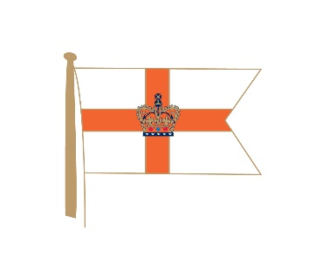
ROYAL YACHT SQUADRON
COMMODORES INVITATIONAL REGATTA
1 – 3 JULY 2024

ORGANISING AUTHORITY
ROYAL YACHT SQUADRON

Amendment # 2
Notice of Race
9. Schedule
9.1 Table for day three
Delete “1025” first warning signal.
Replace with “0955” first warning signal.

Rob Brown RO
2nd July 2024

